Raw Datasets Archive Service
This section provides more detailed information about the use of the dataset archive containing the raw data of DiverSea Data Space. To access the service the user needs to go to the following link:
https://datafiles-diversea.gate-ai.eu/ WP2/T2.1/<case study>/data/
where <case study> parameter is the name of one of the DiverSea case studies
- Black_Sea
- Turkish_Waters
- Hellenic Islands
- Adriatics
- Balearics
- Atlantic_Coast
- Norwegian_Coast
The raw data repository is implemented as a virtual Internet file system on a dedicated server in GATE Institute network. Due to security restrictions the credentials to access the raw data in the repository are registered to the work package leaders who can grant them only to members of their teams.
The raw data repository allows only browsing and downloading the original datasets without any modification to protect the original data. Due to its relatively small volume, the separate dataset files can be downloaded directly from the Web site without a wired transfer. Fig. 2 shows an example of raw data containing abiotic measurements of water samples from the Adriatic Sea coast, collected by the partners from Universita Politecnica delle Marche (UNIVPM).
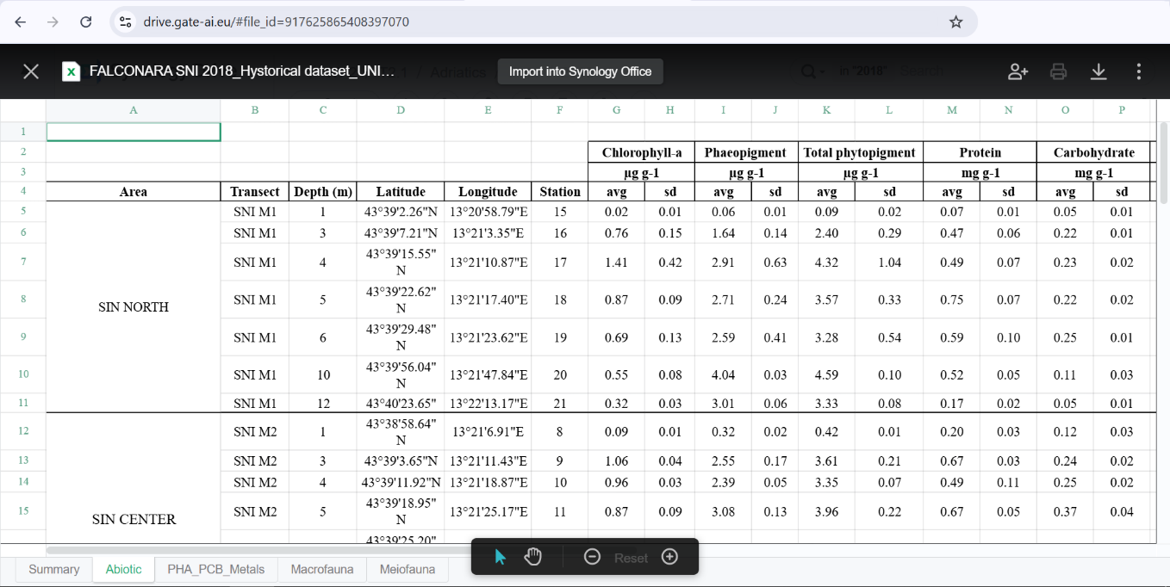
Figure 2. Underwater measurements from Adriatic Sea datafiles (https://datafiles-diversea.gate-ai.eu)
Additional external data, generated outside DiverSea project can be also stored in the archive in accordance with the Data Management Policy of the project, but it is a subject of approval by the case study leaders and deliberation with DiverSea Data Space administrator (email: stoyan.nikolov@gate-ai.eu). After integration with the European environmental and biodiversity data repositories the datasets will be also downloadable via Copernicus and EmodNet services at
https://dataspace.copernicus.eu/copernicus-services
https://emodnet.ec.europa.eu/en/emodnet-web-service-documentation#data-download-services

